SNPWA CHQ Dec 31st 2022

Brief recapitulation of what occurred during the year 2022

Sanchar Nigam Pensioners’ Welfare Association (SNPWA) was formed in August 2019 at Bangalore based on a resolution in the CWC of SNEA. Unfortunately immediately after its birth the outbreak of the pandemic hindered it's full- fledged activities due to the severe restrictions around. Still it has always held its heads high in the pensioner community through committed, dedicated and sincere all round activities

While recapping the events of 2022, we will not gloat about our achievements, but only the facts, because that is the ethos on which we work
Well Comrades, as every year,this year also comes with a mixed bag, some excellent results, some good one and a few not very good. But the balance, we should frankly admit, tilts heavily in favour of our achievements. Most of you will already be recapulating and recounting on the happenings. So we will pen only the most important ones
1. The case of the ST Comrades of Maharashtra, which we have been pursuing from the beginning of last year, entered into its final phase during this year, despite the hostilities that we had to face from different quarters, particularly in the top echelons of BSNL and some at the CCA. Ninety percent of the affected comrades received their due payments through the year. But still a few remain. We will fight until the last one of them gets his eligible benefits. That is why we recently met Hon. Chairman of the Parliamentary standing Committee for SC/ST affairs, even last week. The number of doors that we knocked in the process is countless. But we have no regrets, because, we know that we are doing our job and that will never tire us. Comrades, we will not let injustice permeate in the society even to the last of our brethren. The fight will go on until it's total resolution.
2. The crucial issue of pension revision, which everyone is eagerly awaiting, is progressing fast. The former Sec. DOT Sh. Anshu Prakash and the then MOC had literally consumed our hopes to the flames. But our relentless pursuit at all levels of the hierarchy, resulted in an online interview granted to our Association on 25th February with Secy( T) where we boldly and strongly presented our unassailable right for pension revision on the basis of the relevant orders and rules in this connection. The Sec T was quite convinced of the genuiness of our arguments and for the first time in a space of four years, we could make him understand that our pension revision was not dependent on wage revision of the serving employees but was at par with other Central Government retirees. The ice was broken. This was the first ever interview granted to any Association thus far by the Sec T. Sh. Rajaraman. You know how we earnestly followed up the issue at all levels, including Hon. MOC, Hon. MPs, DOP& PW, not being the least of them. But our main focus was in the DOT, where the primary and crucial job was to be carried out, including the modalities and fitment on revision. The Member (S), Member ( F), Director (E), DDG (E) were all met to monitor each stage of development of the case and give them appropriate inputs to stake our claim for the best fitment. We are continuing our job and sooner than later we will ensure that BSNL/ MTNL pensioners get the duly deserved pension revision wef 01.01.2017. Comrades, please remember that the fight has so far been hard and will be harder and harder with the passing of every day. It is a long long way to go with the path towards reaching final goal post strewn with insurmountable hurdles which we have no choice but to overcome through undaunting and never looking back struggle. Frankly speaking still, we have miles and miles of very difficult terrain to traverse till we reach our destination. But with unwavering determination we will carry on the fight with indomitable conviction and till tangible results are attained. Comrades We should thank the Hon. MOC, Secretary T, Member S, Member F and all others who have given us a patient hearing during the entire process, by which we have been able to make reasonably good progress.
3. Medical allowances.
BSNL is going through hard times. But the medical allowances and bills of the pensioners could not be let alone for years. Our interaction with the CMD BSNL on the subject ensured that all pending medical bills are settled by suitable allotment of funds. The way in which the issue has been dealt with by various Circles, did not stand up to our expectations. We have once again requested for fresh funds for Circles which report lack of funds for the same. The Dir F has promised to allot more funds on request from needy Circles.
4. Fast track refund of CGHS contributions.
We had initially proposed direct payment of CGHS contribution from BSNL itself on behalf of desirous pensioners. Thankfully, the CMD agreed fully to this proposal. Unfortunately, due to software upgradation issues, direct payment could not be effected. Thereupon our next step was to demand for fast track refund. The Management agreed to make the refund within 30 days. Even though 31.03.2022 was initially set as the last date for such fast track refund, on our request it was extended by one year upto 31.03.2023. The pensioners will be greatly benefited by such arrangements.
5. Tax on refund of CGHS contribution.
The order on taxability of gratuity, CGHS refund etc issued by BSNL was a point of contention ever since it was issued in 2021. We wanted the BSNL CO to revisit the orders. Though the order on taxability of gratuity was withdrawn on our intervention. However, the tax consultants of BSNL CO opined that the refund was a perk and hence taxable. We have taken up the issue with the CMD. And on his advice we have held preliminary discussions with the new Dir. F. We will be going the whole mile to get it settled in our favour.
6. The fixation issue of officiating JTOs of Kerala regularised in 2008/2009 has been a bone of contention since long. We took it up very strongly with BSNL CO, who issued favourable orders. But Kerala Circle office was not able to carry out the spirit of the orders. We have once again taken up the issue with BSNL CO with about 15 annexures supporting our cause. We are pursuing the case very strongly and expect early resolution.
7. Understanding the financial crisis through which BSNL/MTNL is going through, we encouraged the pensioners to largely migrate to CGHS from BSNL MRS. The response was quite good. At the same time we are fully well aware of the infirmities of the CGHS, which range from
a. Insufficient penetration of WCs especially in the rural segment
b. Even in the few Wellness Centres, the acute scarcity of empanelled hospitals
c. Insufficient fund allocation to the scheme which remains unenhanced.
d. The shortage of staff and facilities in the WCs.
e. The insufficiency of medicines in the WCs.
f. The steps to do away with ALCs.
We addressed all these issues at various levels of CGHS including the Ministry of health & family welfare. We do not claim that all these have been settled but we know that our timely interventions have had a large impact. A couple of months back we could secure an allotment of 840 crores from the MOF and the MOH & FW for clearing the pending hospital bills. We will continue our efforts to establish a better environment for the beneficiaries. We know that it cannot be done in a day. And that is why we are here - to take up your problems and issues on a day to day basis.We will continue to fight for the pensioners with great concern to their aging health issues.
8. The inadequacy of both the CGHS and the BSNL MRS scheme was well understood by us. To make life better for our ailing brothers and sisters, we have been able to set up SNPWA CHQ Health Insurance Scheme, which has been extending immense help to so many of our needy brothren. We are keeping it open to all retirees of BSNL/MTNL/ DOT, because we believe in the brotherhood of all pensioners irrespective of Association affiliations. To our great satisfaction, the scheme has become an instant hit a cross-section of pensioners joining it and utilising it's benefits with the least bother or hassles.
The salient features of the scheme are
i. Caters to all age groups
ii. All pre-existing diseaes are covered unlike other schemes where there is a waiting period of 3 to 4 years.
iii. No caps in treatment.
iv. Even though it is a IP scheme, a number of daycare procedures including angiogram, angioplasty, dialysis etc are covered without IP admission
v. Very low premium compared to similar portfolios
vi. Very strong and comitted force to handle medicals issues with least hassles
vii. Wide network of empanelled hospitals across the legth and breadth of the country for cashless treatment.
and many more.
The scheme has been running successfully fir the kast two years. The next issue is also receiving huge response. More than all that we are extremely happy that we have been able to be of immense help to so many including cancer, kidney, cardiac and other patients.
9. We are presently planning to take upon our shoulders vehicle policies also not for expanding or diversifying our activities but to extend hassle-free service to the aging pensioners at very low costs
10. Immediately on our formation, our VRS comrades started facing issues on payment of ex-gratia which was not going along the guaranteed lines. We took up the issues at DOT/ Government levels and our strong voice did not go unheeded.
11. Concession on FTTH Connections on the line of RSTC was another matter concerning the pensioers. We projected it before the concerned authorities and ensured that eligible concession is provided to FTTH Connections and today we are happy that all retirees are enjoying the benefits because of our timely intervention and action.
12. FMA facilities, for those falling beyond 5 km radius of the concerned WC, which were hitherto set apart only for CDA pensioners, are now extended to BSNL/ MTNL retirees also on migration to CGHS. Our intervention on the subject produced positive results
13. An OA for raising the ceiling of income tax on ex-gratia and leave surrender is under process and is expected to be filed shortly I Kerala High Court. We have very strong contentions particularly since the ceiling limits in both cases remain unrevised for more than 20 years, now.
14. Similarly notices served to some retirees U/S 243 of IT act on leave surrender during DOT period is being followed up. The Association has laid down a set of procedures to be followed on individual basis. We believe that the IT department will realise the legal justification and admit the same. Most of the cases of retirees following the procedure outlined by the Association have been settled. If, there is any negative thoughts from the concerned IT Commissioner, the Association will think of approaching ITAT to get the required remedy.
We have found great favour and support from the Pensioner community based on our staunch, strong and productive actions. As a result our membership is growing on a daily basis. All Circles) Districts report huge hikes in our membership. Shortly we will touch the 10000 mark. We are happy that we are finding favour with pensioners in other Associations, as well. We are not in the habit of poaching. At the same time we welcome all those who feel that we are doing well and standing with the cause of the fraternity. We will continue in the same committed, determined and strong-willed way all through. We have no other cause but the welfare of the entire pensioner community.
The New Year beckons us with numerous challenges. And we shall face them with rare commitment and hard work. If you are with us we can make sure that the New Year is ours...The future is ours

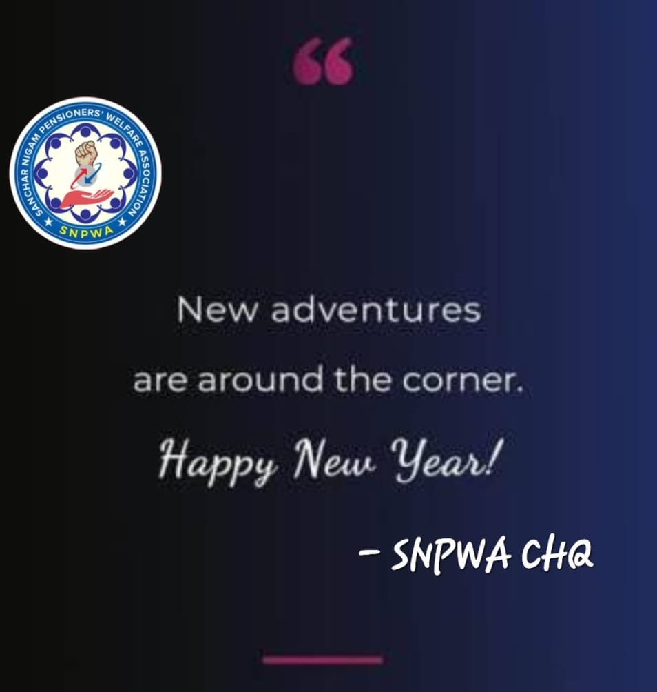

Happy New Year and all the best.

G.L.Jogi
General Secretary
SNPWA CHQ

